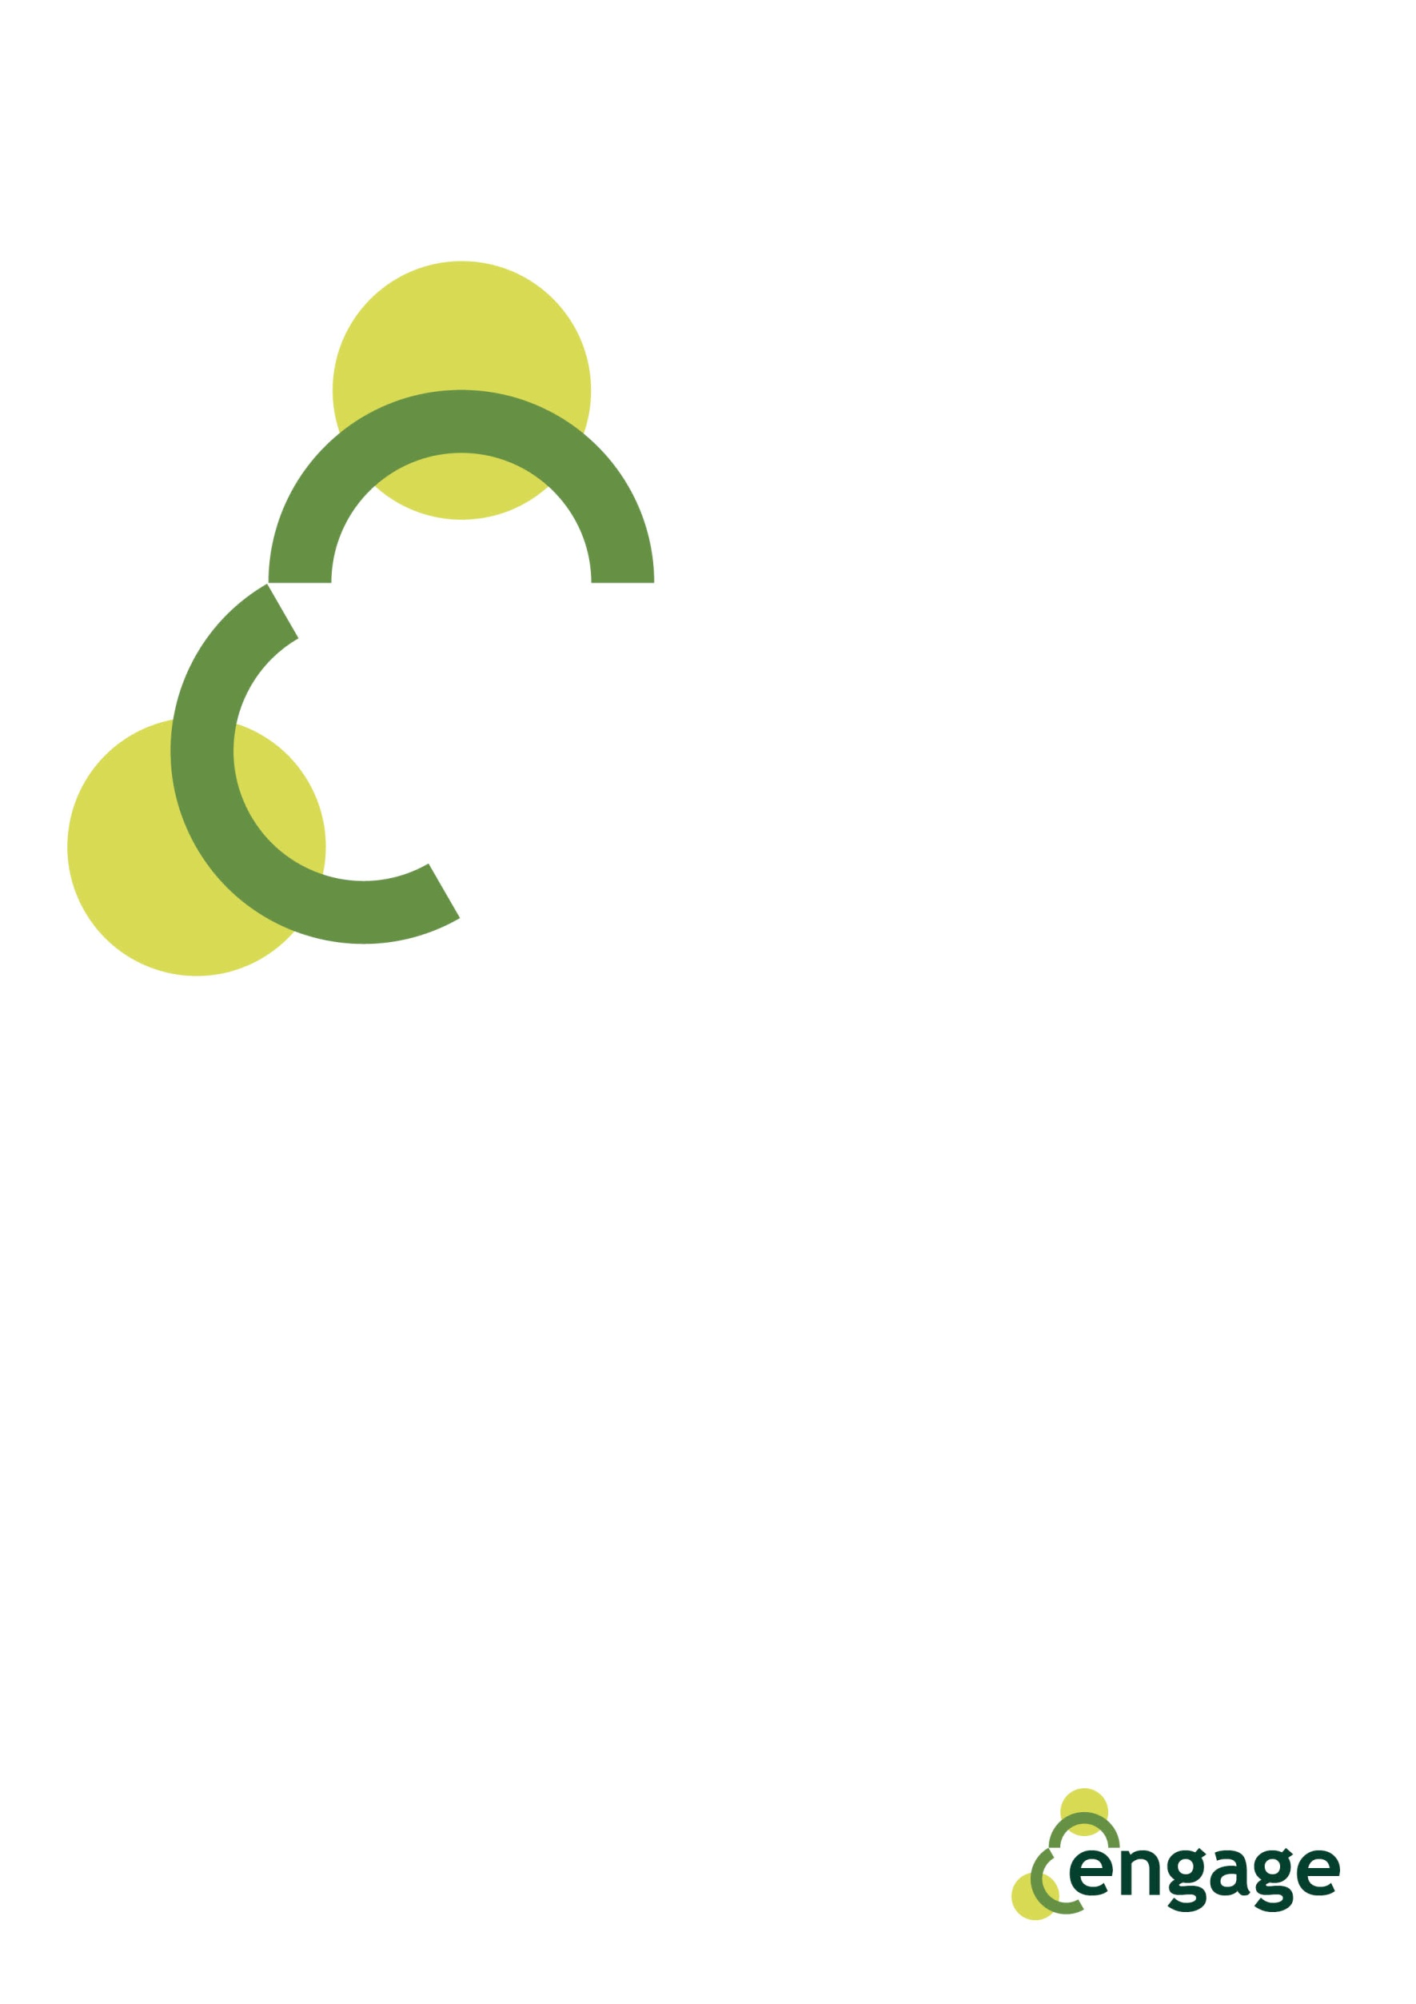
Our common home: Europe

Script

Slide 1 text | This resource wants to valorize the role of our common home: Europe. In fact, several times we forget why Europe is important and what is the meaning of “Our” and “Common”.
Slide 2 text | We will try to surf through 5 issues. First of all, we will go deeper into the motto of the European Union and we will analyse the 12 stars represented on the EU flag. Then we will say some word on the infrastructure and institutions of the EU, underlining that it is quite impossible to understand the decision-making process on which it is based on. The last section – the long one - will explain what are our common values.
Slide 3 text | The motto of the European Union is “United in Diversity”. It was decided in 2000. Proposals came from more than 80.000 young people aged between 10 and 19 from all Europe.  To explain the meaning of the motto, it is important to refer to the preamble to the Treaty, where there is underlined that “peoples of Europe, while remaining proud of their own national identities and history, are determined to transcend their former divisions and, united ever more closely, to forge a common destiny”.  So, it means that being part of the European Union will add values to our lives, not the opposite. It is like adding another gold medal, another star on the chest.
Slide 4 text | And by the way, if we refer to stars, our common flag is made by 12 golden stars on a blue background. The 3 elements represented there have to be considered. First of all, the circle that is a symbol of unity, of the absolute and of perfection. It represents also the parity of the Member States because in a circle all the points of the circumference are equidistant from the centre.  Then, the 12 stars represent independence, unity, liberty, renewal and hope. Why 12? Because it is considered to be an ideal number. Do you remember how many signs of the zodiac there are? And the months of the year? And what about the hours of the day? And those of the night? And the labours of Hercules?  Last but not least, the blue chosen for the background is the colour of the sky and the universe.  In a general way, the flag of the European Union expresses harmony, peace and respect and balance.
Slide 5 text | And when we talk about balance, all homes and houses are built in a balanced way. So now we can talk about the infrastructure and institutions of the EU. We will say only some words about the principal institutions, trying to inspire you and to convince you to go deepen autonomously.  First of all, all strategic decisions are taken by the European Council in their “summits”. Here, all the heads of state or government of the 28 EU member states are represented. It is supported by the Council. Its Presidency rotates every 6 months. The Council disposes, the European Commission proposes. In fact, it has the power to propose and draft law. It is the “government” of the Union and each state is represented. Nearly 500 million European citizens are represented by 751 members in the Parliament. The European Parliament is the only directly elected body in the Union.  The last institution on which we will say something is the European Central Bank. It is the bank for the states adopted the euro (19 out of 28 member states) and aims to maintain price stability.  Are you curious and want to go deepen? Take a look in the publication section of the official website of the European Union.
Slide 6 text | Of course, now we know how you feel: a little bit confused. And no one word has been said yet on the decision-making process. But let’s do like that: we will try to make it simple. From your side, you have to promise you will study it autonomously.  Let’s start.  Two decision-making procedures are in place: the standard one (called codecision) and the special one. Let’s see only how codecision works, because the special one is a residual procedure.  The Commission proposes new initiatives consulting interested parties through public consultations. The Parliament and Council review and propose amendments. Decision is taken only when all involved institution (Commission, Parliament and the Council) agree on it and “vision” is fully shared by them.  P.s: remember you promise to go deepen autonomously!
Slide 7 text | Now we will take a look to common values on which “our home” is based on. In the next 5 slides, we will approach 16 principles stated in the EU Charter of Fundamental Rights. I would like to remember you that European Union is “founded on the indivisible, universal values of human dignity, freedom, equality and solidarity (and on) the principles of democracy and the rule of law”. That’s what we have to remember to “share a peaceful future based on common values”. So, let’s start our trip toward them.  First of all:  - Human dignity is inviolable  - no one shall be condemned to the death penalty, or be held in slavery  - Everyone has the right to liberty
Slide 8 text | - Everyone has the right to freedom of thought, religion, opinion  - Everyone has the right to have access to education  - Everyone has the right to work  - Everyone is equal and diversity is respected
Slide 9 text | - Any discrimination based on sex, race, colour, ethnic, social origin, genetic features, language, religion, belief, political or any other opinion, membership of a national minority, property, birth, disability, age or sexual orientation shall be prohibited.  - Equality between men and women must be ensured in all areas, including employment, work and pay
Slide 10 text | - Children shall be protected  - Elderly shall lead a life of dignity and independence  - Persons with disabilities are protected and supported  - Independent and impartial tribunal are established to assure the rule of law
Slide 11 text | - All citizens have the right to good administration  - Everyone is presumed innocent until proved guilty according to law  - Every citizen of the Union has the right to move and reside freely within the territory of the Member States.

